Skinner
B.F. Skinner was born on March 20, 1904 in Susquehanna, a small railroad town in the hills of Pennsylvania just below Binghamton, New York.
With one younger brother, he grew up in a home environment he described as “warm and stable”.
His father was a rising young lawyer, his mother a housewife. Much of his boyhood was spent building things – for example a cart with steering that worked backwards (by mistake) and a perpetual motion machine (the latter did not work). Other ventures were more successful. He and a friend built a cabin in the woods. For a door to door business selling elderberries, he designed a flotation system to separate ripe from green berries. When working in a shoe store during his high school years, he made a contraption to distribute the “green dust” that helped the broom pick up dirt.
In high school, Skinner took an English class taught by Miss Graves to whom he was later to dedicate his book, The Technology of Teaching. Based on a remark by his father, he blurted out in class one day that Shakespeare had not written As You Like It, but rather Frances Bacon. When his teacher told him he didn’t know what he was talking about, he went to the library and read quite a bit of Bacon’s works. Bacon’s championing of the inductive method in science against the appeal to authority was to serve him well later.
First Encounters with Behavioral Science
After attending Hamilton college, Skinner decided to become a writer.
Moving back home he wrote little. His entire production from the period he called his “dark year” consisted of a dozen short newspaper articles and a few models of sailing ships. Escaping to New York City for a few months working as a bookstore clerk, he happened upon books by Pavlov and Watson. He found them impressive and exciting and wanted to learn more.
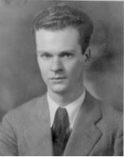
Graduate School and Discovery
At the age of 24 Skinner enrolled in the Psychology Department of Harvard University. Still rebellious and impatient with what he considered unintelligent ideas, Skinner found a mentor equally caustic and hard-driving. William Crozier was the chair of a new department of Physiology. Crozier fervently adhered to a program of studying the behavior of “the animal as a whole” without appealing, as the psychologists did, to processes going on inside. That exactly matched Skinner’s goal of relating behavior to experimental conditions. The student was encouraged to experiment. Each department, Psychology, and Physiology, assumed the other was supervising the young student, but the fact was he was “doing exactly as I pleased”. With his enthusiasm and talent for building new equipment, Skinner constructed apparatus after apparatus as his rats’ behavior suggested changes. After a dozen pieces of apparatus and some lucky accidents (described in his A Case History in Scientific Method), Skinner invented the cumulative recorder, a mechanical device that recorded every response as an upward movement of a horizontally moving line. The slope showed rate of responding. This recorder revealed the impact of the contingencies over responding. Skinner discovered that the rate with which the rat pressed the bar depended not on any preceding stimulus (as Watson and Pavlov had insisted), but on what followed the bar presses. This was new indeed. Unlike the reflexes that Pavlov had studied, this kind of behavior operated on the environment and was controlled by its effects. Skinner named it operant behavior. The process of arranging the contingencies of reinforcement responsible for producing this new kind of behavior he called operant conditioning. Because of a fellowship, Skinner was able to spend
his next five years investigating not only the effect of following consequences and the schedules on which they were delivered, but also how prior stimuli gained control over behavior-consequence relationships with which they were paired. These studies eventually appeared in his first book, The Behavior of Organisms (1938)
Freud
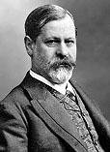 | Sigmund Freud  1856 - 1939  Sigmund Freud was born in the Austro-Hungarian Empire in 1856. His father was a small time merchant, and his father's second wife was Freud's mother. Freud had two half-brothers some 20 years older than himself. His family moved to Vienna when he was four years old, and though he often claimed he hated the city, he lived there until it was occupied by Germany in 1938. Freud's family background was Jewish, though his father was a freethinker and Freud himself an avowed atheist.  Freud was a good student, and very ambitious. Medicine and law were the professions then open to Jewish men, and in 1873 he entered the University of Vienna medical school. He was interested in science above all; the idea of practicing medicine was slightly repugnant to him. He hoped to go into neurophysiological research, but pure research was hard to manage in those days unless you were independently wealthy. Freud was engaged and needed to be able to support a family before he could marry, and so he determined to go into private practice with a specialty in neurology.  During his training he befriended Josef Breuer, another physician and physiologist. They often discussed medical cases together and one of Breuer's would have a lasting effect on Freud. Known as Anna O., this patient was a young woman suffering from what was then called hysteria. She had temporary paralysis, could not speak her native German but could speak French and English, couldn't drink water even when thirsty, and so on. Breuer discovered that if he hypnotized her, she would talk of things she did not remember in the conscious state, and afterwards her symptoms were relieved -- thus it was called "the talking cure."

Jung
Carl Gustav Jung was born on July 26, 1875, in Kesswil, Switzerland, the son of a minister. At the age of four, the family moved to Basel. When he was six years old, Carl went to the village school in Klein-Huningen. His father also started teaching him Latin at this time. During his childhood, Jung preferred to be left alone to play by himself. He was happiest when he was in isolation with his thoughts.
As Jung grew older, his keen interest in a large variety of sciences, and the history of religion made the choice of a career quite difficult. However, he finally decided on medicine, which he studied at the University of Basel (1895–1900). He received his medical degree from the University of Zurich in 1902. Later he studied psychology (the scientific study of the mind and its processes) in Paris, France.
In 1903 Jung married Emma Rauschenbach. She was his loyal companion and scientific coworker until her death in 1955. The couple had five children, and lived in Küsnacht on the Lake of Zurich.
Jung began his professional career in 1900 as an assistant to Eugen Bleuler (1857–1939) at the psychiatric clinic of the University of Zurich. During these years of his internship, Jung, with a few associates, worked out the so-called association experiment. This is a method of testing used to reveal affectively significant groups of ideas in the unconscious area of the psyche (the mind). These groups or "complexes" as Jung called them, would have a control over the affected person, and would encourage anxieties and inappropriate emotions.
When Jung read Sigmund Freud's (1856–1939) Interpretation of Dreams, he found his own ideas and observations to be basically confirmed and furthered. He sent his publication Studies in Word Association (1904) to Freud, and this was the beginning of their
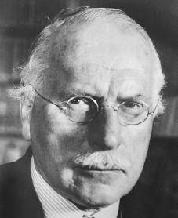
Carl Jung.
Courtesy of the
Library of Congress
.
work together, as well as their friendship, which lasted from 1907 to 1913. Jung was eager to explore the secrets of the unconscious psyche expressed by dreaming, fantasies, myths, fairy tales, superstition, and occultism (belief in supernatural powers or forces).

Bowlby
Born in London, England, Bowl-by graduated from Cambridge University in 1928 and began his professional training at the British Psychoanalytic Institute as a child psychiatrist. He was trained in the neo-Freudian object-relations approach to psychoanalysis, which taught that children's emotional disturbances were primarily a function of their fantasies generated by internal conflict. While embracing the psychoanalytic emphasis on the importance of the early years for children's healthy emotional development, Bowlby felt that this approach neglected the importance of their actual early experiences with their parents.
After World War II, Bowlby became the head of the Children's Department at the Tavistock Clinic, where he focused his clinical studies on the effects of mother-child separation. He completed a monograph for the World Health Organization on the sad fate of homeless children in postwar Europe and collaborated with James Robertson on a film, A Two-Year-Old Goes to the Hospital. These works drew the attention of child clinicians to the potentially devastating effects of maternal separation, and led to the liberalization of family visiting privileges for hospitalized children.
Unsatisfied with the psychoanalytic view that the child's love of mother derived from oral gratification, Bowlby embraced the ethological theories of Konrad Lorenz and Niko Tinbergen, which stress the evolutionary foundations of behavior as a source of explanation for mother-child attachment relationships. He presented his first formal statements of ethologically based attachment theory to the British Psychoanalytic Society in 1957. Bowlby argued that mother-child attachment has an evolutionary basis, promoting the child's survival by increasing mother-child proximity, particularly when the child is stressed or fearful.
Maslow
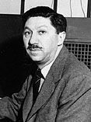 | Abraham Maslow  1908 - 1970  "I was awfully curious to find out why I didn't go insane," remarked Abraham Maslow, one of the founders of humanistic psychology.  He was born and raised in Brooklyn, the eldest of seven children. He was smart but shy, and remembered his childhood as lonely and rather unhappy. Maslow attended City College in New York. His father hoped he would pursue law, but he went to graduate school at the University of Wisconsin to study psychology. While there, he married his cousin Bertha, and found as his chief mentor Professor Harry Harlow. At Wisconsin he pursued an original line of research, investigating primate dominance behavior and sexuality. He went on to further research at Columbia University, continuing similar studies. He found another mentor in Alfred Adler, one of Freud's early followers.  From 1937 to 1951, Maslow was on the faculty of Brooklyn College. In New York he found two more mentors, anthropologist Ruth Benedict and Gestalt psychologist Max Wertheimer, whom he admired both professionally and personally. These two were so accomplished in both realms, and such "wonderful human beings" as well, that Maslow began taking notes about them and their behavior. This would be the basis of his lifelong research and thinking about mental health and human potential. He wrote extensively on the subject, borrowing ideas from other psychologists but adding significantly to them, especially the concepts of a hierarchy of needs, meta needs, self-actualizing persons, and peak experiences. Maslow became the leader of the humanistic school of psychology that emerged in the 1950s and 1960s, which he referred to as the "third force" -- beyond Freudian theory and behaviorism.  Rogers  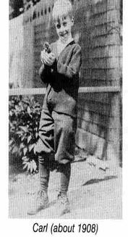  Carl Ransom Rogers was born on January 8, 1902 in Oak Park, Illinois, a suburb of Chicago. His father Walter A. Rogers, was a civil engineer and his mother, Julia M. Cushing was a devout Christian. Carl was the fourth of their six children. Rogers was intelligent and could read well before kindergarten.  When Carl was 12, his family moved to a farm about 30 miles west of Chicago, and it was here that he was to spend his adolescence. With a strict upbringing and many chores, Carl was to become rather isolated, independent, and self-disciplined. (Carducci, 2009, p.206)  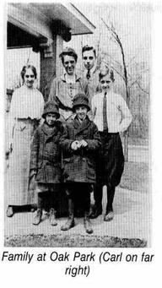  Rogers went on to the University of Wisconsin as an agriculture major. Later, he switched to religion in order to study for the ministry. He received his B.A. in 1924. During this time, he was selected as one of ten students to go to Beijing for the “World Student Christian Federation Conference” for six months. He recounts that his new experiences so broadened his thinking that he began to doubt some of his basic religious views.  After graduation, he married Helen Elliot, with the reluctant approval of his parents. He moved to New York City, and attended the Union Theological Seminary, a famous liberal religious institution. While there, he took a student organized seminar called “Why am I entering the ministry?” 'I might as well tell you that, unless you want to change your career, never take a class with such a title!' He said that most of the participants “thought their way right out of religious work.”  Religion’s loss was, of course, psychology’s gain: Rogers switched to the clinical psychology program of Columbia University, where he received his M.A. in 1928, and his Ph.D. in psychotherapy in 1931. He had already begun his clinical work at the Rochester Society for the Prevention of Cruelty to Children. At this clinic, he learned about Otto Ranks theory and therapy techniques, which started him on the road to developing his own approach. (Rogers, 2004, p.3)  Alfred Adler  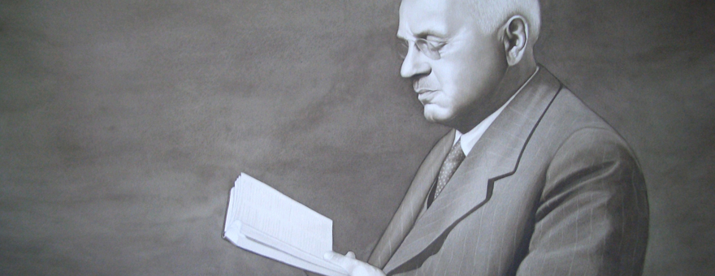  Adler was born just outside of Vienna on February 7, 1870. After graduating with a medical degree in 1895 from the University of Vienna, he began his career as an ophthalmologist, but soon switched to general practice in a less affluent area of Vienna near an amusement park and circus. Working with people from the circus, Adler was inspired by the performers’ unusual strengths and weaknesses. It has been suggested that Adler began to develop his insights on compensation and inferiority during this time.  In 1907 Adler was invited to meet with Sigmund Freud. Adler and Freud, along with Rudolf Reitler and Wilhelm Stekel, began meeting weekly during “Wednesday Night Meetings” that eventually grew to begin the psychoanalytic movement. Together, they formed the Vienna Psychoanalytic Society, of which Adler was the first president.  Although Freud looked upon Adler as one of his first disciples, Adler never viewed himself that way, and broke with Freud and Freudian psychoanalysis in 1911. Many of Adler’s concepts and ideas were separate from Freud’s, particularly regarding the importance of the social realm. Adler used these ideas to form individual psychology, and founded the Society of Individual Psychology in 1912.  After serving as a doctor in the Austrian Army in World War I, Adler established a series of child guidance clinics in Austria and embarked on extensive lecture tours in the United States and Europe. To significant acclaim, he successfully promoted his psychological concepts emphasizing social interest, or gemeinschaftsgefühl.  After his Austrian clinics were closed due to his Jewish heritage, Adler emigrated to the United States where he began a professorship at the Long Island College of Medicine. In 1937, while on a lecture tour in Aberdeen, Scotland, with his student and Adler University founder Rudolph Dreikers, Alfred Adler died of a heart attack. His body was cremated in Edinburgh, but the ashes were never reclaimed. They were rediscovered in a casket at Warriston Crematorium and returned to Vienna for burial in 2011.  Karen Horney  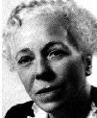  Karen Horney  Karen Horney was a pioneering theorist in personality, psychoanalysis, and "feminine psychology".  Horney was born near Hamburg, Germany on September 16, 1885, the second child of Clotilde and Berndt Wackels Danielson. Although her father often bought her gifts and took her on exciting trips, she felt ignored by him. She thought that he was too strict and that he favored her older brother, Berndt.  Growing up was not an easy process for Karen. She battled depression from the time she was nine, stemming from the crush that she had on her brother followed by the rejection she felt when he rejected her love. At around the same time, she became very ambitious and rebellious. As she did not see herself as an attractive girl, she was certain that doing good in school was the best alternative. She once said, "School is the only true thing after all".  As a young woman, important milestones and great pressure plagued Karen. Three years after her acceptance into college, Karen was married to Oskar Horney, a law student that she had met in school. In 1910, Karen gave birth to their first of three daughters, Brigitte. Just one year later, her mother died. Next, Horney gave birth to her second and third daughters, Marianne and Renate, in 1913 and 1916, respectively. Karen turned to Freudian analysis to help her through these difficult, tiring times.  Karen's education was a major contributor to her fatigue. She had to justify her actions for going to medical school to her family in 1906, a time when society did not find importance in rewarding girls for their hard work in the classroom. Education and university admittance became available to women in Germany only a few years earlier, in 1900. She entered the University of Freiburg in 1906, one of the first universities in Germany to admit women as matriculated students. Of the 2,350 students at the university in 1906, only 58 were women. In 1908, she transferred to the University of Gottingen along with her husband. She graduated from the University of Berlin in 1913, earning her medical degree.  In the same way her father was, Oskar proved to be a harsh father. His business soon shut down and he became quite ill, adding to his temperament. Her brother's death, along with her husband's behavior, contributed to Karen's depression and suicidal thoughts in 1923. In 1926, Karen and her daughters moved out of Oskar's home, waiting until 1930 to set up a life in the United States.  Horney's career began at the Institute for Psychoanalysis in Berlin, where she taught from 1920 to 1932. Karl Abraham worked with her and regarded her as one of his most gifted analysts. Karen's first American job was as the Associate Director of the Chicago Institute for Psychoanalysis, a position she held for two years.
Erik Erikson
Erik Erikson was born in Frankfurt, Germany on June 15, 1902 to Karla Abrahamsen, a young Jewish woman. Although married, she was living her family at the time of the birth, having moved in after leaving her husband, Valdemar Salomonsen. A Jewish stockbroker, Salomonsen had fled the country four years earlier in connection with fraud and criminal ties. Karla Abrahamsen had engaged in an extramarital affair in his absence and become pregnant. She never disclosed the specific identity of her son's biological father, merely that he was of Danish extraction. She listed her son's surname as "Salomonsen". Four months later, word arrived that she was newly a widow; Valdemar Salomonsen was dead.
Abrahamsen trained as a nurse and eventually remarried, when young Erik was about three years old. Erik's new stepfather was his pediatrician, Theodor Homburger. Homburger, who insisted on being referred to as Erik's father, conferred his surname on the boy in 1908 and finally adopted him in 1911. Despite this it became apparent, with the arrival of three half sisters, that Erik held a very different place in the family as the adopted stepson. Throughout adolescence he increasingly identified as an outsider, both within and in the local community. He was teased at school for being Jewish, and at synagogue for being tall and blond. His stepfather refused to accept his intense artistic inclinations.
When Erik finished gymnasium, he refused to go to medical school (as his stepfather wished) and abandoned home to enroll in Baden State Art School. A year later, he took time off for travel. Ultimately, he ended up in Vienna where, among other things, he painted children's portraits. A friend, Peter Blos, recommended that Erik expand on this by tutoring and teaching art at a school run by Dorothy Burlingham, a friend of Anna Freud, daughter and intellectual heir of the famed Sigmund Freud. The Hietzing School, as it was called, was organized along psychoanalytic principles, and many of the students were the children of Freud's patients and friends.
Seeing Erikson's skill with children, Anna Freud began mentoring him. (Note that he was actually still Erik Homburger at the time). His training, which included regular psychoanalytic sessions with Ms. Freud, resulted in a certificate from the Vienna Psychoanalytic Society. At the same time he attended classes at the University of Vienna, and also earned his teaching degree and a certificate in the Montessori method. He continued to teach, to become more involved in psychoanalysis. He also became married to Joan Serson a dance teacher at the Hietzing School. Eventually, economic pressures and the rise of the Nazis prompted the couple, which now had two sons, to move to Copenhagen, and then to the U.S.
Erikson's initial efforts to set up shop in the U.S. as a child psychoanalyst were at first stymied by his lack of an advanced degree. So he worked for a time as an assistant professor and research assistant at Harvard and Yale. He took some graduate level courses, but ultimately it was his ties with members of the Vienna Psychoanalytic Society that won him professional acceptance. He moved to the San Francisco Bay area, and took a position as a research associate and a lecturer at the University of California at Berkeley. Soon he was able to start his practice, at last, eventually becoming an important member of the bay area's psychoanalytic community, and even serving as president of the San Francisco Society and Institute in 1950.
Meanwhile he had applied for U.S. citizenship, which was granted in 1939, and he had legally changed his last name to Erikson. Supposedly the named choice was influenced by his eldest son who liked the idea of continuing the Scandinavian tradition of being bearing the father's name as part of the surname. However there is some very slight indication that "Erik" may have been the name of his own biological father as well.

