**AP MICROECONOMICS Name: ________________________**

**Study Guide Perfect Competition**

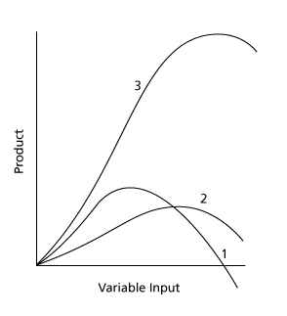

1. The graph above displays 3 curves: **Marginal Product. Total Product** & **Average Product** of Labor (workers).
   1. Label the appropriate curves as: MP, TP and AP
   2. Explain in some detail the reasons for the shape of the **marginal product of labor** curve
   3. Explain how MP affects the shape of the TP curve. When MP = 0, Total Product is at a_______________?

**_______________________________________________________________________________________________**

**_______________________________________________________________________________________________**

**_______________________________________________________________________________________________**

**_______________________________________________________________________________________________**

**_______________________________________________________________________________________________**

1. Label all 4 **cost curves** below:

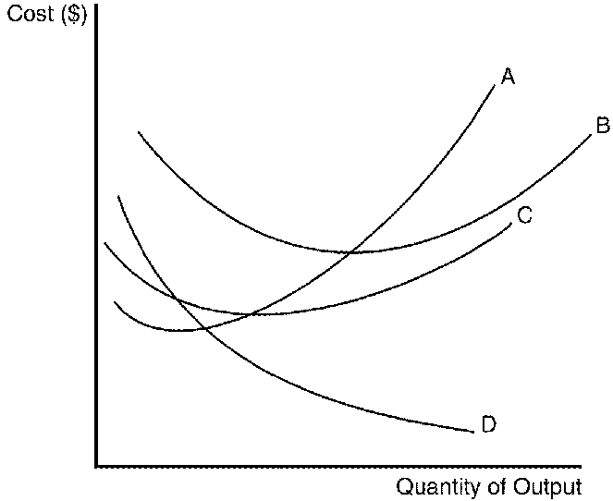

1. Explain why **curve D** starts very high on the Y axis and approaches the X axis but never touch it?

______________________________________________________________________________________________________

______________________________________________________________________________________________________

1. At what point does curve A cross curve B and cross curve C?
   1. Clearly explain why this is true.

______________________________________________________________________________________________________

______________________________________________________________________________________________________

______________________________________________________________________________________________________

1. Explain what happens to **ATC** (average total cost) during a period of **economies of scale**?
   1. Recall that economies of scale is a LONG RUN concept

______________________________________________________________________________________________________

______________________________________________________________________________________________________

1. List the **five market characteristics** of **Perfect Competition**: (also called a competitive market)
   1. Categories: # of firms, type of product, ease of entry/exit, information, price control

**↓ ↓ ↓ ↓ ↓**

______________________________________________________________________________________________________

Perfect comp

1. Clearly explain why an individual firm in a competitive market has a **horizontal demand curve**?
   1. What does this imply about the relationship of Price, Average Revenue & Marginal Revenue?

______________________________________________________________________________________________________

______________________________________________________________________________________________________

1. Explain why whenever an individual firm in a competitive market sets **MC = MR** they will **maximize profit**?
   1. Hint: think of the profit on the very last unit!

______________________________________________________________________________________________________

______________________________________________________________________________________________________

______________________________________________________________________________________________________

1. The market is in equilibrium at a price of $60. Please fill in the following table and find the profit maximizing level of production for this individual competitive firm.
   1. ***Hint:*** *Price = MR for a competitive firm. (they have a horizontal demand curve!)*
   2. Calculate the short run profit for this competitive firm: ___________________________ (P – ATC) * Qty
   3. Fixed costs are ________ Does this firm have any area of economies of scale: _____________

|  |  |  |  |  |  |  |  |  |
| --- | --- | --- | --- | --- | --- | --- | --- | --- |
| **Quantity Produced** | **Total**  **Cost** | **Marginal**  **Cost** | **Average**  **Total C.** | **Average**  **Variable C.** | **Quantity Demanded** | **Price** | **Total**  **Revenue** | **Marginal Revenue** |
| 0 | 100 | -- | -- | -- | 0 | 60 | -- | -- |
| 1 | 150 | 50 |  |  | 1 | 60 | 60 | 60 |
| 2 | 202 |  |  | 51.00 | 2 | 60 |  |  |
| 3 | 257 |  | 85.66 | 52.33 | 3 | 60 |  |  |
| 4 | 317 |  | 79.25 | 54.25 | 4 | 60 |  |  |
| 5 | 385 |  |  |  | 5 | 60 |  |  |
| 6 | 465 |  | 77.5 | 60.83 | 6 | 60 |  |  |

**MC table Perfect Competition Textbook**

1. The graph above is for an individual firm in a competitive market. Based on the graph & Marginal Cost Table above at a market price of $8: (remember they are a price taker!)
   1. How many units would be produced: __________
   2. What is the economic profit for this firm? __________ Accounting profit? *(above or below economic?)*
   3. If market demand rose causing price to rise to $14 dollars
      1. How many units would be produced: ______________
      2. Calculate the economic profit of this firm (show calculations…)
      3. Draw the **profit area** in the graph above

______________________________________________________________________________________________________

**Long Run Perfect Competition Equilibrium**

1. Based on the graphs above list 3 requirements for a competitive market to be in **long run equilibrium**

* **- ________________________**
* **- ________________________**
* **- ________________________**

1. Analyze the difference between the **short run supply curve** and the **long run supply curve** for an individual firm
   1. Hint: think ATC & AVC Make sure you mention the terms **SHUTDOWN** & **EXIT** in your analysis

______________________________________________________________________________________________________

______________________________________________________________________________________________________

______________________________________________________________________________________________________

______________________________________________________________________________________________________

1. Discuss the difference between the **long run supply curve** of the entire competitive MARKET vs. **long run supply curve** for an individual curve. (from question 12)
   1. Hint: firms in the long run must produce at minimum of ATC. (see market graph below)

______________________________________________________________________________________________________

______________________________________________________________________________________________________

______________________________________________________________________________________________________

**Long Run Perfect Competition Equilibrium**

1. Modify the graphs above for the impact of a **short run decrease in demand**
   1. Find a new market equilibrium (label point either E1 & E2 or A & B)
   2. Explain why this new equilibrium will not last in the long run in a competitive market
   3. Explain what would likely occur in the long run to secure a new long run equilibrium

______________________________________________________________________________________________________

______________________________________________________________________________________________________

______________________________________________________________________________________________________

______________________________________________________________________________________________________

______________________________________________________________________________________________________

______________________________________________________________________________________________________